Corrosion Problems Related to Aircraft Engines and Rockets, and Their Control

MSE 4010

4/12/2020

Conor Wesolowski

Bishop Wright

Wendi Wu (Allen)

Alex Yang

**Abstract:**

Since the Wright brothers invented the airplane, the aircraft and aerospace industry has become one of the most important tools used by humans to explore the world and space. However, building an aircraft or a rocket is very expensive, so the prevention of corrosion for aircraft and rocket components is essential. The purpose of this paper is to investigate the issue of corrosion and its prevention for aircraft engines and rockets due to the high-temperature oxidation and mixed gases environment. High temperature corrosion can be divided into high temperature oxidation, hot corrosion, carbonization, and sulfidation. High temperature oxidation is mainly the reaction of oxygen and metals at high temperatures to form oxides. Also, exposure to molten salts accelerates corrosion by degrading protective oxides and causing the mechanical properties of the material to deteriorate. The major concept of treatments like coating, increasing rate of diffusion of alloying elements, and thermal protection is creating oxide layers which prevent environmental attack and corrosion of the material.

**Introduction:**

Aircraft engines and rockets have component parts in service at high temperatures. In order to maintain and sustain the key properties of these components, materials used for aircraft engines and rockets need high tolerance of high temperature corrosion issues. Depending on the materials and environmental conditions, the degradation of the engines would be detrimental with the effects of embrittlement or oxidation. The environment for the high temperature corrosion of jet and rocket engines is generally defined as gas composition, temperature, and flow rates. The gas composition from the fuel exhaust includes carbon dioxide, water steam, carbon monoxide, hydrogen, and some oxygen. High temperature oxidation can be complicated as the fuel types vary. Temperature of the engines in aeroplanes and rockets is usually higher than 1000 degrees and could be up to 3500 degrees Celsius. Together within the gaseous environment, oxidation, sulfidation, carburization, and hot corrosion could happen to the materials. These degradation mechanisms would significantly influence the operating time and functionality. High temperature oxidation is a major part of the corrosion seen in airplane engines and rocket heat shields. Many studies have been done with materials such as Ni-based superalloys, Fe-based alloys (steel), Cu-based alloys, Ti-based alloys, and high temperature ceramics, specifically investigating their corrosion effects at high temperatures. The products after combustion or the atmospheric environment contribute to serve as parts of the corrosive environment, and in aircraft engines specifically, certain molten salts can deposit onto the surface of materials leading to a high corrosion rate. For high temperature ceramics used in the heat shields of reentry vehicles, the combination of dissociated ions caused by the plasma formed at the high speeds of reentry, and high temperature oxidation, are the driving forces of corrosion on heat shields of space vehicles or rockets. For selecting material for a rocket engine, both elevated and cryogenic temperature should be considered since the range of operating temperature of rocket engines is quite large. Furthermore, preventing galvanic corrosion and cracking is an essential part for rocket engines.

**Body:**

The aerospace materials used in airplane engines and rockets are prone to high temperature oxidation due to the high operation temperature. This type of oxidation and corrosion is relevant to a great number of applications in aerospace materials, and therefore is drawing attention and experimental effort to obtain a deeper understanding of its underlying mechanisms. The term oxidation (sulfidation, or carborization) refers to the transfer from metal element to metal oxides, and is a thermodynamic process associated with free energy of formation according to equation (1).

(1)

is the equilibrium constant of the oxidation reaction of M and the product of the reaction is MxOy, a metal oxide, as shown in equation (2).

(2)

Where R is the gas constant, T is the temperature and Keq is the equilibrium constant of the oxidation reaction. The base element of the alloys would provide the major properties and the oxidation behavior is reflected by the scales of oxides developed. According to equation (3), the free energy changes with temperature.

(3)

As the temperature increases, the oxides become less stable as oxygen adsorbs onto the surface [1], as seen on the Ellingham Diagram shown in Figure 1. Small amounts of oxygen can form even in mixed gas environments containing very little oxygen due to the nature of reversible gas formation reactions at equilibrium, destabilizing oxides at high temperatures even in low oxygen environments

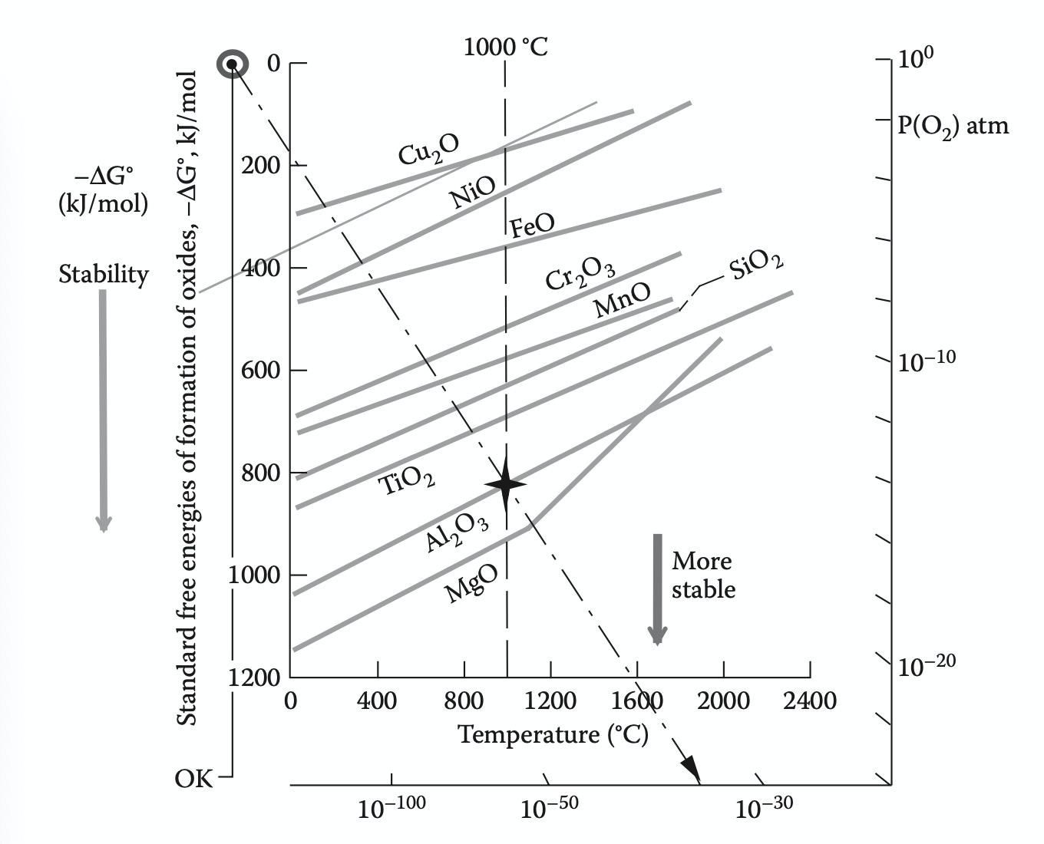

*Figure 1: Ellingham Diagram with indication of relative thermodynamic stability of the metal oxides.*

The oxidation of alloys is a more complicated process compared to oxidation of metal. The formed oxide would form separate phases or dissolve into each other. Besides, the metal contents would differ in oxygen affinity, so the oxidation rate varies between different metal components. Complex oxide compounds would form as the oxidation occurs. As the metal oxides vary in diffusion rate, the oxides form at different rates under the high temperature conditions and the oxide would be seen either on the surface as scale or at the interface of different phases. Alumina is important in alloys’ stability, corrosion resistance, and refractory properties, with high activation energy and a high melting point. In order to maintain the mechanical properties of the metal alloys, the secondary oxides would be developed to assist primary Alumina film protection. For example, the development of the secondary oxides such as Cr, Si in Ni and Al-based oxides would further prevent NiO formation in Ni-based alloys, improving the efficiency of the protective effect of the oxide film with given materials contents. The oxidation rate of alloys is affected by the oxide film’s adherence, melting point, vapor pressure, difference in thermal expansion coefficients relative to parent metal, plasticity, and electrical conductivity. Alumina scale adhesion is strongly influenced by the sulfur effect. Adhesion of the scale oxides is also affected by the humidity, with the consequential embrittlement of alumina or aluminide films. Many methods of increasing resistance to high temperature corrosion involve the addition of alloying elements. These additives form stable oxides to produce a protective film, reducing further oxidation of the material. However, this strategy can also affect the other properties of the material. Such a strategy is often not feasible in many elements, with titanium alloys and titanium aluminides as a notable example, where excessive addition of alloying elements reduces ductility and plasticity severely, such that the component can no longer perform its designed function [2]. Coatings which form stable oxide films may also be applied to materials for greater resistance to high temperature oxidation.

Grain size of materials is also a factor in determining susceptibility to high temperature oxidation. Notably, materials with grains of less than 100 nanometers, or nanocrystalline materials, have a much larger volume fraction of grain boundaries and increased diffusibility of their alloying elements than materials with larger grains [3]. As a result, greater resistance to high temperature corrosion was seen in the nanocrystalline version of multiple materials such as K38G, KF17, and LDZ125, than in their microcrystalline counterparts. The greater proportion of high energy sites on the surface, like grain boundaries and triple junctions, provides more sites for oxide nucleation and therefore facilitates the formation of a protective oxide layer which imparts resistance to further oxidation.

Additionally, the increased rate of diffusion of alloying elements allows for additives such as Cr and Al to more quickly reach the surface and react with the environment to form the protective oxide layer. Increased diffusibility also lowers the concentration of solute required to favor external oxidation, or the formation of a protective oxide film, over internal oxidation, or formation of isolated oxides in the sub-surface. This results in the formation of a protective oxide film at lower concentrations of the active alloying elements, potentially reducing the cost of the alloy. These effects are also seen if only the coating is nanocrystalline rather than the entire component. However, nanocrystalline materials are prone to growth of grains and loss of these properties at relatively low temperatures unless the grain boundary energy is lowered by the addition of appropriate alloying elements to kinetically or thermodynamically stabilize the material. It is also important to consider that the material composition must already favor formation of a protective oxide film for this formation to be enhanced by a reduction in grain size.

While some other alloys such as copper and iron based alloys degrade easily at high temperatures, Ni-based superalloys are one alloy that has been widely used in aerospace applications for its resistance to high temperature corrosion and creep. The typical Ni-based superalloy contains Cr (5-10 wt %), Co (5-10 wt %), Mo (0-2 wt %), Ti (0-2 wt %), Al (5-6 wt %), and other elements such as Ta, Nb, W and balance Ni. It is believed that the addition of Al and Cr provides the oxidation resistance while other elements form segregates, increasing strength through precipitation hardening [4]. However, corrosion of Ni-based superalloy is still worthy of attention at high temperatures. Sulfur present in jet engine exhaust attacks oxygen or sulfur-active elements to form segregation at the interface of the alumina and metal base, largely weakens the bonding of interfacial area, and can lead to corrosion of the metal previously protected under alumina films. Reducing the Sulfur content decreases the chances of segregation, and increases the alumina filming protection. On the other hand, the brittle intermetallic phase of Ni-Al is also detrimental in high temperature corrosion. Many studies show that the 𝛃-NiAl has poor resistance to high temperature creep, and the efforts to increase the strength further increase the brittleness. High brittleness in turbine hardware would lead to more unwanted failure. Additionally, the transient alumina formed on the interface boundary would have 𝜃-alumina phase transformation at high temperature above 900 degrees Celsius [5]. The transformed 𝜃-alumina is susceptible to radial cracking due to residual stresses from the transformation. The doping elements segregate on the grain boundaries, reducing the tendency of the transformation. Some doping elements could resolve the cracking from the transformation, while water vapor would greatly promote the cracking. Additionally, the intermetallic phase of Ni-Al embrittlement is detrimental in high temperature corrosion. It is found that the superalloys degrade when Al is depleted by inter-diffusion to the base materials, as the Al is no longer available to form alumina protective scales [6]. Many coating techniques were developed other than Al oxide film protection, including diffusion and overlay coatings, which are also used to mitigate hot corrosion in high temperature environments.

The alloying elements and their oxide effects contribute to the high temperature corrosion resistance of Ni-based superalloy materials. Addition of Mo and W strengthens the superalloy via solid solution hardening as the γ′-Ni3Al phase is produced. Cr and Al forms oxides of Cr2O3 and Al2O3, reducing the formation of the less protective NiO film. Al2O3 film is stable at high temperatures when the material is under operation, which reduces the oxidation rate of the material. Such Ni-Al based coating is essential for superalloys to provide protection under the high temperature oxidation corrosions. Alumina filming protection of the superalloy reduces its oxidation in high temperature applications, allowing the Ni-based superalloy to reach 1300 degrees Celsius without deterioration in its strength or other mechanical properties. One innovative new Ni-based super-alloy, Haynes 282 has been introduced to replace Waspaloy and R41, two commercially widely used super-alloys in aerospace materials.

Hot corrosion is another issue that can occur as a result of the extreme temperatures found in aircraft engines and rockets. This phenomenon happens when molten salts, most prominently Na2SO4, condense on the surface of the alloy [7]. These salts damage the protective oxide layer on the surface of the component, rendering it an ineffective barrier against the aggressive environment. They can form during combustion as a result of a reaction of the sulfur in the fuel with sodium contaminants found in the atmosphere, fuel, or industrial pollutants. Alternatively, sodium sulfate can also form from a reaction of NaCl with oxygen and sulfur during combustion. NaCl and V2O5 are other molten salts which can cause hot corrosion.

At temperatures from 850-950 Celsius, type I hot corrosion occurs. The molten salts cause an initial failure of the protective oxide layer on the surface through chemical reactions, thermal stresses, or erosion corrosion, depending on the composition of the surface oxide and the molten salt. This leaves the alloy exposed to the molten salt, where corrosion can occur in several ways. The first involves direct sulfidation-oxidation reactions of the alloy with the molten salt, similar to the reactions with gases seen in high temperature corrosion. The second mechanism is known as salt fluxing. In this mechanism, the oxide layer becomes dissolved and moves through the molten salt layer, either by combining with an O2- anion (basic fluxing) or decomposing into its cation form, then combining with an O2- anion (acidic fluxing). This removal of the protective oxide layer results in much faster corrosion of the alloy.

At lower temperatures (650-800 Celsius), type II hot corrosion occurs. This type of corrosion requires a mixture of the sodium sulfate with another metal sulfate, such as CoSO4, with a lower melting temperature to stability at lower temperatures. These additional metal sulfates are typically formed during combustion as part of a reaction between metal atoms from a component and SO3. The metal oxide film on the component surface is locally destabilized by sulfation, forming more of the necessary metal sulfate to mix with sodium sulfate. Cobalt-based alloys are especially susceptible to this behavior. This mechanism then continues, degrading more of the metal oxide film, exposing the alloy to the corrosive environment. Sulfidation of the component also plays a role in type II hot corrosion of other metal alloys, such as nickel-based alloys.

Alloys high in chromium have been shown to be resistant to hot corrosion, whereas alloying elements added for strength, such as vanadium and tungsten increase susceptibility. Common chromium metal oxides like Cr2O3 reach with sodium sulfate to form a stable solute, thereby stopping further dissolution of the metal oxide. Secondary phases, especially coarse metal carbides, often increase susceptibility, by selective attack at boundaries or the more vulnerable phase. The application of protective coatings is a common method of increasing hot corrosion resistance. These coatings can be diffusion coatings, where the surface of the material is enriched with alloying elements which produce stable oxide films, overlay coatings, where a specialized alloy with high resistance to hot corrosion is added to the surface of the material, or thermal barrier coatings, where the coating material is deflects heat from the material underneath. Finally, risk of hot corrosion can be reduced by washing components to discard the molten salts and by filtering the air and ensuring there are no contaminants in the fuel to prevent the possibility of molten salt formation. Those methods of coating are often used for protection of aircraft engines and blades frequently exposed in flight.

Corrosion failure is commonly seen in navy aircraft engine blades, and is closely related to the environment of marine aircraft engines, the marine atmosphere. For compressors, the long-term exposure to environments with high air humidity, high temperature, and heavy salt fog causes the salt particles in the ocean atmosphere [8] to deposit on the surface of the compressor blade, which increases the conductivity of the liquid film on the metal surface. The large quantity of aggressive chloride ions exacerbates the electrochemical corrosion of compressor blades. Normally, industries which are developed nearby coastal areas produce pollutants such as chloride gas, sulfur dioxide, carbon monoxide, and others into the atmosphere. The presence of these pollutants further exacerbates the electrochemical corrosion of fan blades in navy aircraft engines along with the influence of sulfur dioxide. Turbine blades undergo high temperature oxidation and hot corrosion during engine operation, which, when compounded by the effects of the marine environment, can cause failure of these components. The incidence of this corrosion can be reduced by effectively controlling the humidity around the engine.

Regarding the potential corrosive environments in rockets or launch vehicles, the reentry environment provides one of the most intense and energetic environments seen during the course of a space mission. The intensity of the corrosive environment depends on the type of rocket launch, i.e., a rocket or spacecraft returning from interplanetary travel will be going much faster than a rocket that is returning from a low earth orbit. Thus, different thermal protection systems (TPS) are necessary to ensure either survivability of the vehicle or potentially enable reusability (in either case, protection of the vehicle from the ultra high temperature environment is required).

Before the different types of TPS are introduced, the actual corrosive environment should be detailed. In atmospheric reentry from space, a vehicle traveling at thousands of miles an hour must slow to subsonic speeds before parachutes can be deployed. Thus, the kinetic energy must be disposed of in the form of frictional and compression heating between the fast moving vehicle and the molecules in the atmosphere it is entering. This heating generates plasma at enormous temperatures, requiring unique, ultra high temperature materials to withstand the heat and protect the vehicle from extensive, potentially catastrophic corrosion of the vehicles and its inhabitants. As this plasma environment is created with the vehicle entering the gaseous atmosphere, dissociation of atmospheric components such as N2 and O2 occurs, and these dissociated ions can chemically combine and corrode the TPS material via chemical reaction or

generation of additional heat: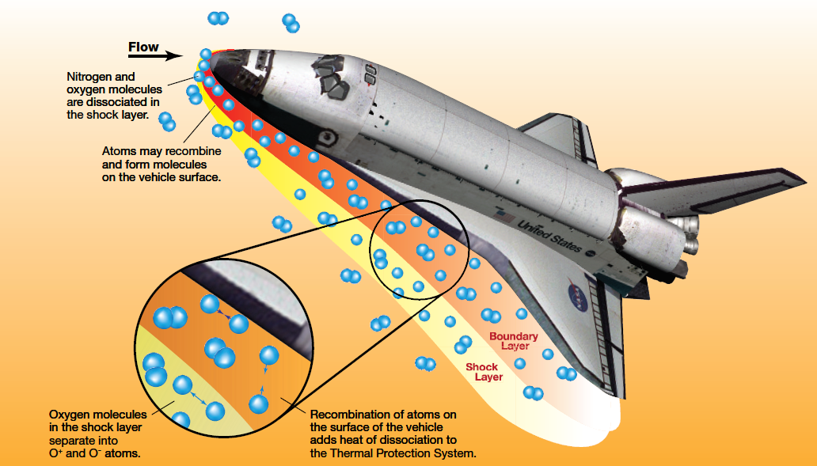

*Figure 2: Dissociation of atmospheric molecules adds heat and potentially corrosive reactions to the TPS surface [12].*

In addition to corrosion from these dissociated ions, efforts must be made to ensure oxidation of the TPS materials does not occur. The oxidation reaction of the silica fibers used in TPS tiles can easily form either SiO or SiO2, the former of which can escape as a gas, leading to mass loss and a rapid decrease in mechanical performance [9]. Nitrogen can also play a crucial role in advancing the oxidation of silica fibers, and it has been suggested in literature that the combined oxidative power of nitrogen and oxygen dissociated ions in the reentry environment can be especially corrosive [9].

Historically, two systems (with two very different corrosive environments) are used to overcome this immense engineering challenge. The first, more traditional approach, is to use ablative TPS systems. Ablation may be defined as removal of surface material by melting, vaporization, sublimation, or chemical reaction [10]. Ablative heat shields are thus designed to corrode in the hot plasma environment, and it is the product of this corrosion that provides protection of the rest of the vehicle. More specifically, ablatives such as the one used on the Apollo moon missions (pictured below in Figure 3) employ pyrolysis of a phenolic polymer with a metal alloy structure to provide mechanical support:

*Figure 3: Apollo 9’s heat shield after reentry, displaying the charred pyrolysis product of the phenolic resin with steel honeycomb supporting structure visible.*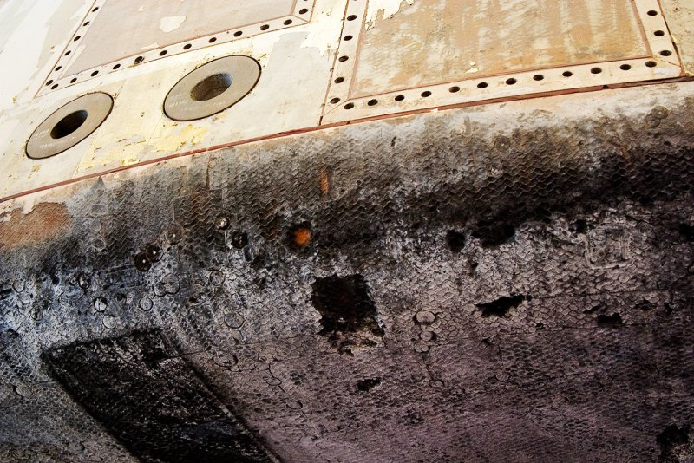

The gaseous products of this pyrolysis corrosion end up providing a protective endothermic layer between the hot plasma and the reentry vehicle, ensuring the temperature of the vehicle does not exceed designed limits. Ablatives have traditionally been applied in spacecraft that are returning from interplanetary missions (e.g. the Apollo moon missions), as the kinetic energy of these craft was simply too much for older reusable TPS materials to handle.

Regarding the other system, reusable TPS can be most famously found on the Space Shuttle. This vehicle was designed for transit to and from low earth orbit, which notably yields slower reentry speeds (i.e. lower kinetic energy) than those found on interplanetary craft such as the Apollo moon missions. These systems are specifically not designed to corrode, and thus do not employ the protection of a pyrolysis gas layer as protection. Instead, these materials must be made out of reusable, ultra high temperature materials (usually ceramics). On the Space Shuttle, there were a variety of materials employed in the overall TPS, which utilized hundreds of individual ceramic tiles in the sections of the vehicle that would see the hottest temperatures (3,000 ℉+), as well as thermal blankets on the lower temperature backend of the vehicle (see Figure 2). Concerning the tiles, these materials had to ensure that very minimal heat be conducted to the vehicle's aluminum skeleton, as well as weigh as little as possible for vehicle efficiency purposes [11],[12]. Thus, low density silica fiber tiles called High temperature Reusable Surface Insulation (HRSI) were used as the primary tile structure. Given the extremely energetic and chemically active environment of reentry plasma, these silica tiles had to be coated with a low catalytic glass coating to prevent oxidation and corrosion of the silica tile. This coating was called Reaction cured Glass Coating, consisting of black borosilicate glass with an emittance greater than or equal to 0.8 [13],[14]. This coating was the key to ensuring that the HRSI tiles not only withstood the intense temperatures of reentry (their high emissivity ensured most of the heat encountered was reflected away), but also the large amounts of chemical energy found in the dissociating atmospheric components mentioned previously: 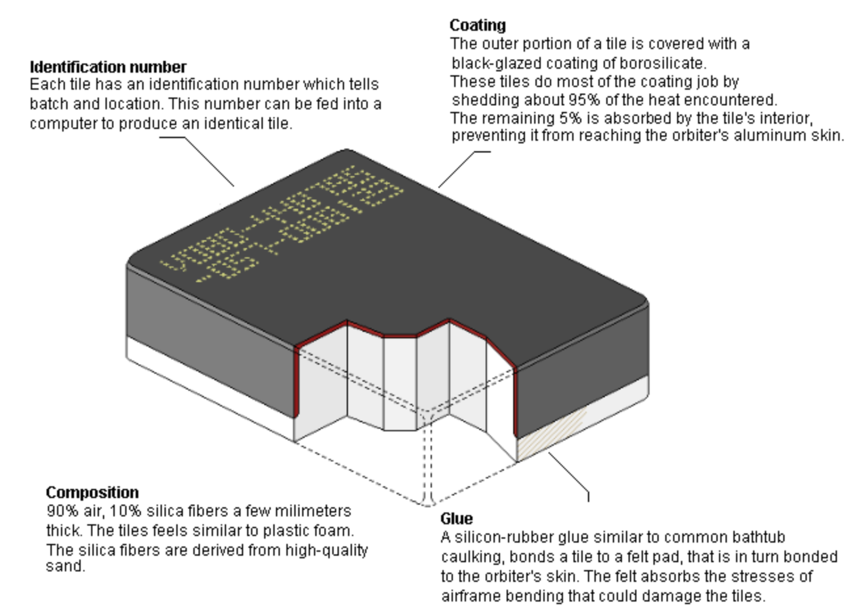

*Figure 4: A diagram of the HRSI Space Shuttle tile, displacing its composition + RCG coating [11].*

Rocket engines experience very large fluctuations in temperature, requiring their components to resist extremely challenging conditions. Aluminum alloys, like 625 and 718, are frequently employed in rocket engines because they are not susceptible to stress corrosion when heat is applied. In the rocket, some high-temperature components such as flame tubes, pipes, turbine blades, flame stabilizers, and exhaust pipes are made of stainless steel, as its high chromium concentration allows for it to develop a stable oxide film which resists oxidation at high temperatures. Although high temperature parts are usually made of corrosion and oxidation resistant alloys, they are susceptible to high temperature corrosion due to high temperature operating conditions. As a result, austenitic stainless steels are preferable when dealing with the lines and duct due to their weldability, ready formability and reasonably good corrosion resistance. [15] Bioethanol is used in a reusable rocket engine fuel since it is quite environmentally friendly. However, under 7 MPa, the sulfur attack takes place when using bioethanol. Combustion of the fuel can result in small quantities of sulfur, causing sulfur attack to occur on the engine [16].

**Summary:**

The extreme environments of aircraft and rocket engines expose the materials from which they are constructed to a unique set of risks. High temperatures reduce the oxygen or sulfur required for oxide formation to miniscule quantities. Molten salt condensation can destabilize protective films and drastically increase corrosion rate. The role of the component in the engine can also create a risk of failure from a combination of corrosive dissolution and environmental stresses. To perform under these circumstances require components to be constructed from materials resistant to these mechanisms. Typically in aircraft engines, these materials form a stable oxide film to prevent rapid destruction of the material. These protective films are stable under these conditions, shielding the susceptible material from attack by the aggressive environment. These oxide layers, or other coating materials, such as high temperature ceramic heat shields, in the case of atmospheric reentry, may also deflect heat from the materials.

They can be formed through oxidation of the alloy itself or oxidation of a coating via a reaction with the environment. Finally, atmospheric reentry produces reactive plasma species with enormous oxidizing power. In these extreme conditions, high temperature ceramic materials are employed to prevent interaction between plasma and space vehicles. Due to the extreme temperature ranges of rocket engines, their components must tolerate large swings in temperature. Therefore, using proper aluminum alloy is extremely essential for preventing rocket engines from corrosion.

**References:**

[1] J. Smialek and N. Jacobson, “Oxidation of High-Temperature Aerospace Materials,” *High Temperature Materials and Mechanisms*, pp. 95–162, 2014.

[2] J. Dai, J. Zhu, C. Chen, and F. Weng, “High temperature oxidation behavior and research status of modifications on improving high temperature oxidation resistance of titanium alloys and titanium aluminides: A review,” *Journal of Alloys and Compounds*, vol. 685, pp. 784–798, 2016.

[3] B. V. Mahesh and R. K. S. Raman, “Role of Nanostructure in Electrochemical Corrosion and High Temperature Oxidation: A Review,” *Metallurgical and Materials Transactions A*, vol. 45, no. 12, pp. 5799–5822, 2014.

[4] A. Nowotnik, “Nickel-Based Superalloys,” *Reference Module in Materials Science and Materials Engineering*, 2016.

[5] B. Chattopadhyay and G. C. Wood, “The transient oxidation of alloys,” *Oxidation of Metals*, vol. 2, no. 4, pp. 373–399, 1970.

[6] J. Stringer, “High temperature corrosion in practical systems,” *Le Journal de Physique IV*, vol. 03, no. C9, 1993.

[7] N. Eliaz, G. Shemesh, and R. M. Latanision, “Hot corrosion in gas turbine components,” *Engineering Failure Analysis*, 16-Oct-2001. [Online]. Available: https://www.sciencedirect.com/science/article/pii/S1350630700000352. [Accessed: 12-Apr-2020].

[8] D. Steensma, “U.S. Navy Aircraft Corrosion Prevention and Control”, *Audit report*, pp 1-32, 1997

[9] P. Dabala, “Investigation of the oxidation behavior of thermal protection materials supported by mass spectrometry,” *Aerothermodynamics for space vehicles, SAO/NASA Astrophysics database*.

[10] M. Rallini, M. Natali, and L. Torre, “An Introduction to Ablative Materials and High-Temperature Testing Protocols,” *Nanomaterials in Rocket Propulsion Systems*, pp. 529–549, 2019.

[11] “HSF - The Shuttle,” *NASA*. [Online]. Available: https://spaceflight.nasa.gov/shuttle/reference/shutref/orbiter/tps/hrcitiles.html. [Accessed: 12-Apr-2020].

[12] A. Rodriguez, “Thermal Protection Systems.” [Online]. Available: https://www.nasa.gov/centers/johnson/pdf/584728main_Wings-ch4b-pgs182-199.pdf. [Accessed: 11-Apr-2020].

[13] A. Huang, “Reusable Materials,” *NASA*, 22-Aug-2017. [Online]. Available: https://www.nasa.gov/centers/ames/thermal-protection-materials/tps-materials-development/reusable.html. [Accessed: 11-Apr-2020].

[14]A. Huang, “Coatings,” *NASA*, 22-Aug-2017. [Online]. Available: https://www.nasa.gov/centers/ames/thermal-protection-materials/tps-materials-development/coatings.html. [Accessed: 13-Apr-2020].

[15]J. Halchak, J. Cannon, C. Brown, “Materials for Liquid Propulsion Systems”, *NASA*, pp 1-58, 2018.

[16] A. Iijima, D. Nakata, M. Sugioka and N. Azuma, “Rocket Engine Feasibility Study for the JAXA Future Transportation Reference System”, *JSASS Aerospace Tech,* vol 12, pp 1-7, 2016